SALARY PREDICTION
INTRODUCTION
In a company of USA,they are trying to support the marketing of a new service targeted at potential customers with medium to high salaries.
There is an initial project setup cost of eighteen thousand dollars, a cost of one hundred and twenty five dollars for each offer made and a return of five hundred dollars for each accepted offer
The current marketing strategy, which involves a high degree of investment per offer has achieved a high acceptance rate in the past of seventy five percent by individuals whose salaries exceed fifty thousand US dollars. The goal is therefore to create a model which can accurately identify individuals whose annual salary exceeds 50,000 US dollars
in future so that they can prepare for project setup cost further

DATA COLLECTION

The data that we used in this project was obtained from the UCI machine learning respository.The dataset contains two sets of data i.e Train.csv and Test.csv (splitted data).I used this dataset to predict the salaries greater than 50k dollars
FEATURES

I used the Adult dataset which contains 15 features for prediction
Age: Ag of the employee
Workclass: type of employer
Fnlwgt: survey weight assigned to individual employee with particular characteristics
Education: education qualification of the employee
education-num: Index of education feature
marital-status: marital status of the employee
occupation: type of employment
relationship: contains similar to marital status values
race: race of employee
sex: gender
capital-gain:income from investment resources apart salary
capital-loss:losses from investment resources apart from salary
hours-per-week: working hours of employee per week
native-country: country employee belong
salary: salary of employee

EXPLORING THE DATA
FEATURE SELECTION:
Using box plots and histograms we visualize the features and decide which features can be useful further
1.Age:From the box plot Figure 1 and from figure 5 Most of the employees with the salary greater than 50K are having similar age range and also the it is bit higher than the class of ‘salary less than 50K’(<=50K),so it might have significance in prediction
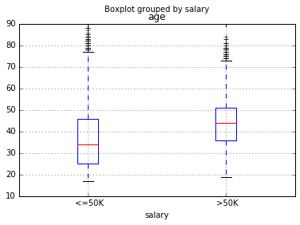
Figure 1
2. hours-per-week:From the figure 2,fig5 ,the range of attribute values is higher in employees with targeted salaries so it might have significance for prediction
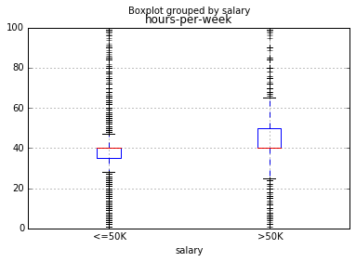
Figure 2

3.education-num:higher range of values so it can also be considered
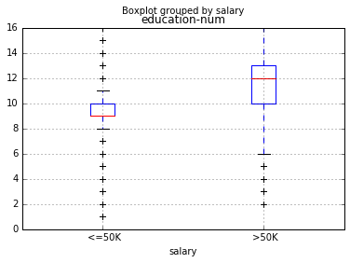
Figure 3

4.education :
From the figure 4,as salary is related to education,it can be considered for the further prediction
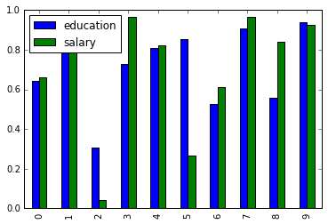
Figure 4
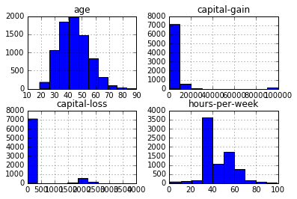
Figure 5:Histograms for continuous variable groupby salary>50K
From Fig:5,for capital loss and capital gain most of the values are zero’s but they are impacting salary>50K ,we can decide further whether to consider for prediction or not

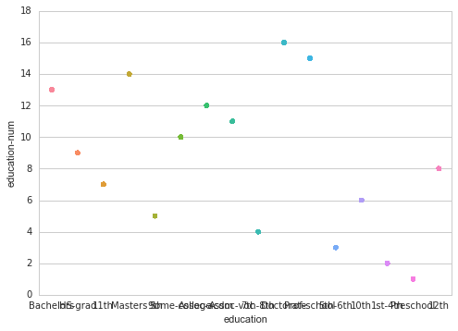 | Here it seems to be education num and education are highly correlated, as the education num is unique to each education value, we can eliminate any of these columns during prediction

Figure 6:Graph btw education-num and education

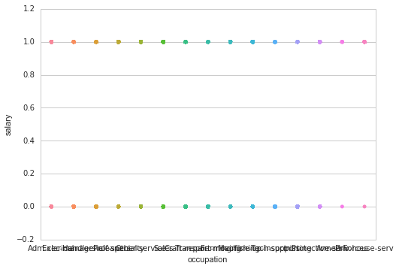 | Here we can find the occupation variable having attribute values for salary greater than 50K it is evenly distributed so it might also helpful in our prediction

Figure 7:Plot between salary and occupation

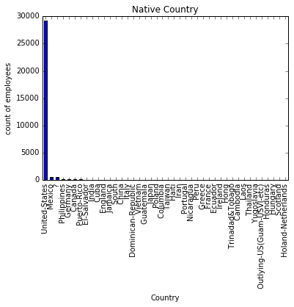  Fig.a:Native-Country distibution | 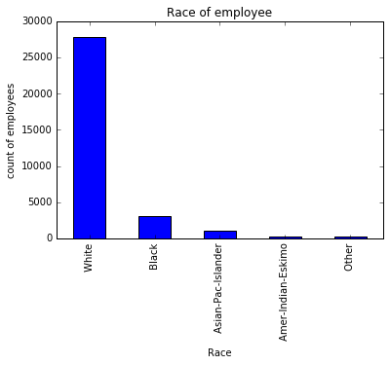  Fig.b:Race Distribution

Native Country and Race can be eliminated as most of the employees belongs to single valued attribute,so it wont make much difference to our prediction they can be eliminated

Sex and marital-status
From Figure C and D,Most of the female employees having salary greater than 50K and also male employees are also having greater than 50K salary,so it might bring difference in our predicition
Attribute values of the Marital-status are also evenly distributed over salary ,so it can also be used in further prediction

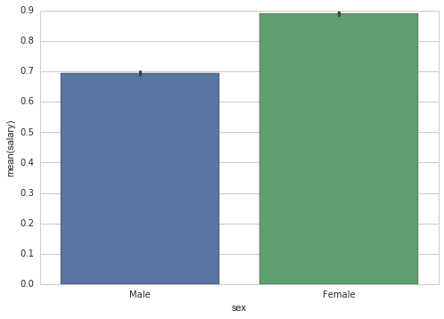  Figure C:Sex Distribution over salary | 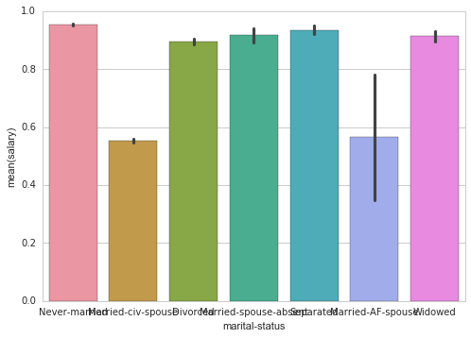  Figure D:Marital status distibution over salary

DATA PREPARATION
FINDING MISSING VALUES
In Dataset we find no missing values for most of the columns except for two columns
Occupation
Work class
We have totally 1843 missing values in both the columns
HANDLING MISSING VALUES
We handle this by either dropping the missing values or by filling the missing values with some mean or most frequent value or with some unknown value,but Occupation and Workclass are categorical values So I filled the missing values with value ‘missing’
CLEANING OF DATA
We got 583 columns in Native-Country tagged as ‘?’,we can replace this symbol by filling the values with most common attribute value occurring in the ‘Native-Country’ column,so we replaced it with ‘United States’
Now our Data is ready for further modeling
MODELING THE DATA :
This is a classification problem, as we need to predict salaries greater than 50K
I preferred to use Random Forest classification for this model
Data Transformation 1:
We consider the following features for firstly modeling
Age, Workclass, occupation, capital-loss, capital-gain, hours-per-week, education,relationship
When we modeled using these features,we got following scores
AUC: 0.808611264664
ROC: 0.782213114017
CLASSIFICATION REPORT:
 | precision | recall | f1-score | support
0 | 0.57 | 0.39 | 0.46 | 3846
1 | 0.83 | 0.91 | 0.87 | 12435
avg / total | 0.77 | 0.79 | 0.77 | 16281

ROC CURVE :
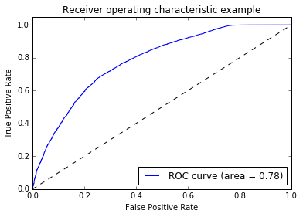

So,Inorder to improve accuracy and performance of our model,I modified the Data little bit by replacing the column values of ‘Relationship’
Husband 13193
Not-in-family 8305
Own-child 5068
Unmarried 3446
Wife 1568
Other-relative 981

To:
married 14761
Not-in-family 8305
Own-child 5068
Unmarried 3446
Other-relative 981

i.e changed attribute values of ‘wife/husband’ to ‘married’
Data Transformation 2:
After modifying the data little bit,we consider again the features
Age,Workclass, occupation, capital-loss, capital-gain, hours-per-week, education,marital-status,relationship for further analysis
When we modeled using these features,we got following scores

AUC: 0.792211780603
ROC: 0.779638770593

ROC CURVE :
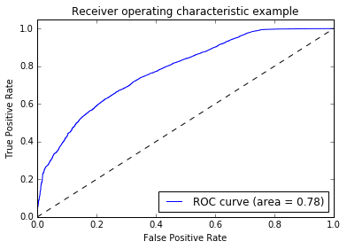

CLASSIFICATION REPORT:
 | precision | recall | f1-score | support
0 | 0.60 | 0.37 | 0.46 | 3846
1 | 0.83 | 0.92 | 0.87 | 12435
avg / total | 0.76 | 0.78 | 0.76 | 16281

Now,we going to eliminate one of the feature ‘Marital-status’ for further modeling

DATA TRANSFORMATION 3:
Used Features:
Age, workclass, occupation, relationship, capital-gain, capital-loss, hours-per-week, education, marital-status
Removed Features:
Fnlwgt,Marital-status,Race,Native-Country,Sex.
Using this set of features we got
AUC: 0.854431545974
ROC: 0.902366951936
ROC CURVE:
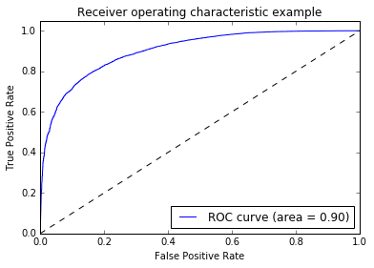
CLASSIFICATION-REPORT
 | precision | recall | f1-score | Support
0.0 | 0.73 | 0.61 | 0.67 | 3846
1.0 | 0.89 | 0.93 | 0.91 | 12435
avg / total | 0.85 | 0.85 | 0.85 | 16281

##Model Performance
* Accuracy of the model: 0.854
* Precision and Recall are : 0.73 and 0.61
* AUC score is 0.90.
So this may be good model.

#EVALUATION
Lets evaluate our performance using CROSS-VALIDATION
Our single holdout AUC score was 0.854. After K-Fold Cross Validation it is clear that our model was pretty good.as the actual AUC of the final model would be between 0.851417 and 0.86 and Average K-Fold CV score (AUC) is 0.855.So our model may work well in Real life scenario
USING OTHER MODEL
Lets consider other model too for prediction
GAUSSIAN NAÏVE BAYES
Using Gaussian NB,I predicted again for the final set features
So the result is:
ROC:0.887260905957

CLASSIFICATION-REPORT:
 | precision | recall | f1-score | Support
0.0 | 0.64 | 0.65 | 0.64 | 3846
1.0 | 0.89 | 0.89 | 0.89 | 12435
Avg/total | 0.83 | 0.83 | 0.83 | 16281

ROC CURVE
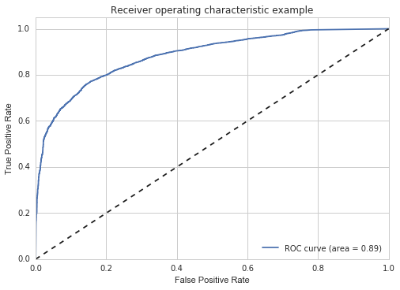
FINAL REPORT
 | >50K PRECISION | >50K RECALL | F1 SCORE
RANDOM FOREST 1st Transformation | 0.57 | 0.39 | 0.46
RANDOM FOREST 2nd Transformation | 0.60 | 0.37 | 0.46
RANDOM FOREST 3rd Transformation | 0.73 | 0.61 | 0.67
GUASSIAN NB | 0.64 | 0.65 | 0.64

CONCLUSION:
So finally we can say
Using Random Forest 3rd Result can give good performance and it is the best model we got use:
73% of the records retrieved having salary greater than 50K but 27% chances of retrieved results failed ,61% of the actual records present in the dataset whose salary greater than 50K are retrieved but remaining docs 39% of the actual results weren't retrieved
Using Guassian NB can give good results as it has High Recall and Low Precision
64% of the records retrieved having salary greater than 50K but 36% chances of retrieved results failed
65% of the actual records present in the dataset whose salary greater than 50K are retrieved but remaining docs 35% of the actual results weren't retrieved
So Using Naïve Bayes we are able to return more positive results(high recall) as it is more than Precision.We can conclude that Using Guassian NB our model has good performance than Random Forest
SUMMARY
We can use this prediction in finding the revenue for the company which offering the new positions for the employees having salary greater than 50K
For Example
we got employees with salary greater than 50K
There by,it is clear from the report that we have 3846 employees with salary greater than fifty thousand dollars, but currently according to market strategy given 75 percent of people are going to accept the offer .So according to this,
The predicted number of employees who going to accept the offer are:
No of employees whose salary greater than 50k dollars * Percent of people according to market strategy
3846*0.75=2,884
Therefore 2884 employees are going to accept the new offer out of 3846 employees in future
Total Revenue would be:
No of acceptance * cost per offer
2884*500=1,442,000 Dollars

REFERENCES:
https://archive.ics.uci.edu/ml/datasets/
http://scikit-learn.org/stable/documentation.html
http://scikit-learn.org/stable/auto_examples/model_selection/plot_precision_recall.html
https://stanford.edu/~mwaskom/software/seaborn/tutorial/distributions.html

